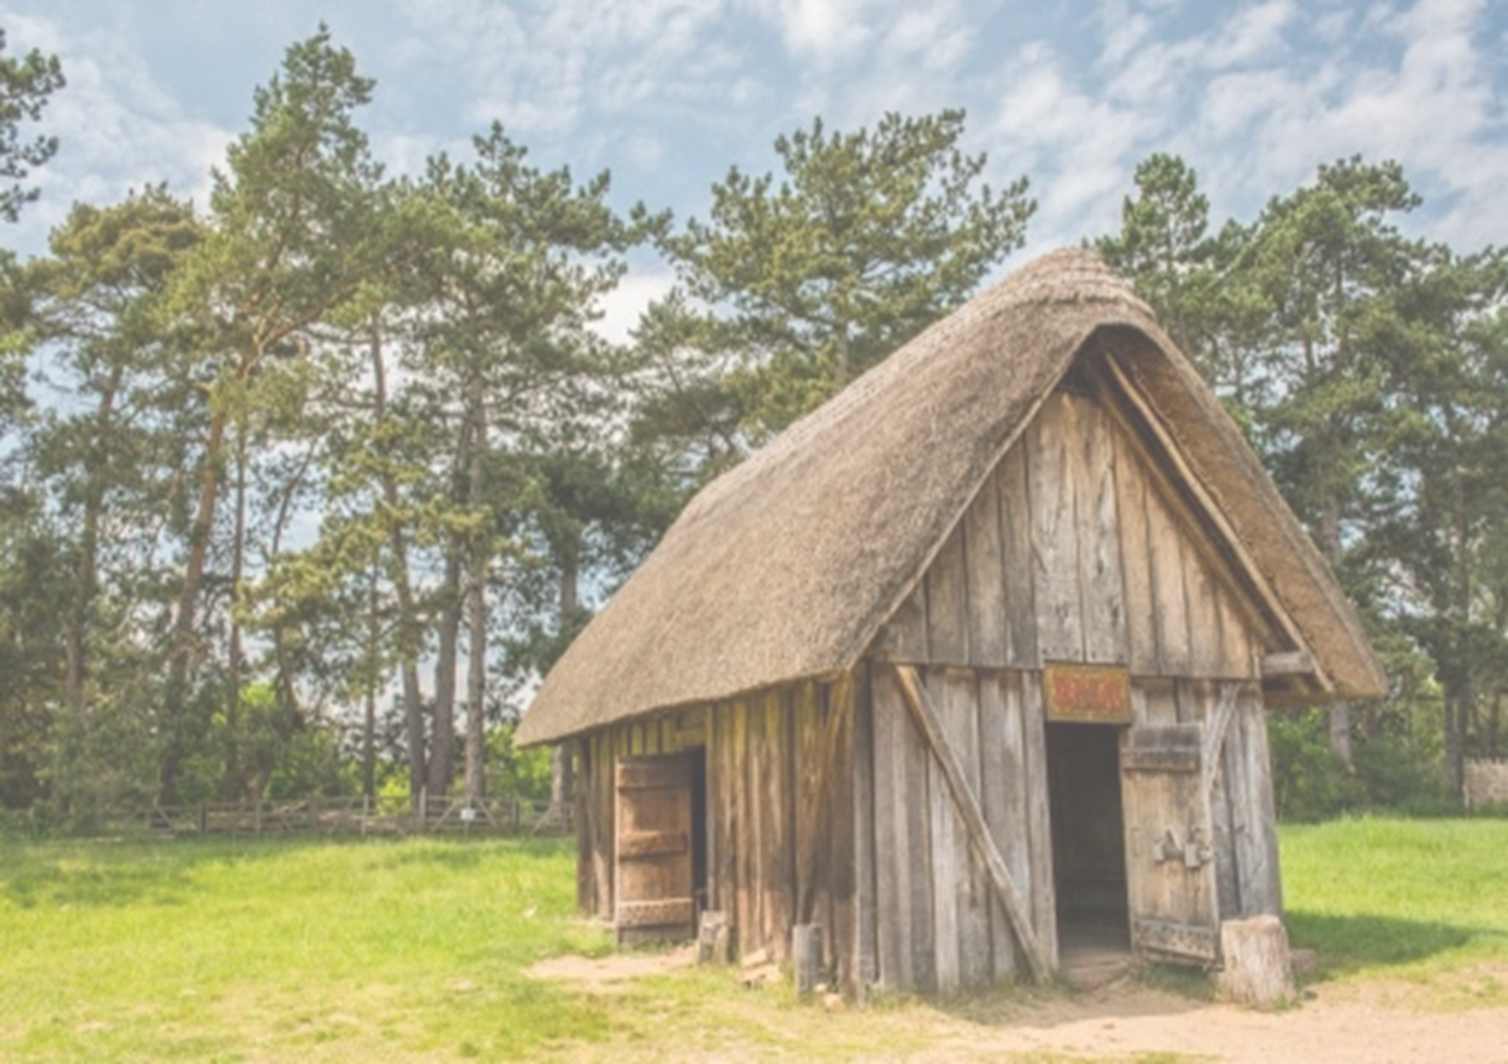

Over the course of this term, we will be exploring our learning through the theme Crime and Punishment. We are looking forward to exploring this topic with the children and encourage them to research as much as they can to develop their knowledge on this topic.

Due to the restrictions with Covid-19, if you would like to discuss any element of your child’s school life, please email or arrange a telephone call with me.

This year, children will need to bring in their PE only on the days when they have PE and the PE kits will be left underneath their tables throughout the day.

Children will need their PE kit in school every Monday and Thursday.

A PE kit should include a Cam Woodfield Junior t-shirt, black or blue shorts and daps or trainers. It is recommended that the children have warm clothes for outdoor PE. This can include a jumper and jogging bottoms.

Finally, if all children’s clothing can be named it makes it easier to return if lost.

Dates to remember:

* Friday 23rd October- Inset Day and break up for half term
* Monday 2nd November- Back in school
* Friday 18th December- Break up from school for the end of term

There will be a particular focus on spellings and times tables (including division facts).

Friday: Times Tables test

Times tables: As a school we are focusing on times tables. It is the expectation of the National Curriculum that children learn their times tables with rapid recall. This means your child will need to learn each times table off by heart- without having to ‘work it out’. All children have log in details to access Times Table Rockstars, which can be used on any smart device via an app as well as on a computer.

Friday: Spelling test

Spellings: The Government have outlined both spelling patterns and exception words that your child must learn.

Children will receive spellings each week and will be tested the following week. Please make sure you are practising the spellings regularly throughout the week. It is important that your child can spell these words and use them within the context of a sentence.

Homework will be handed out every Friday and children will have until the following Wednesday to submit any work. This may change if a homework project lasting more than 1 week is set, however this will be communicated to the children and parents.

Alongside homework, children will have weekly spellings and times tables. They are also expected to read regularly and this should be recorded in their reading record. These are considered part of the homework for the week.

©©©©

**Crime and Punishment**

During Geography we will be looking at the Anglo-Saxons. We will look at where they came from and plotting the journey they travelled to get here on a map and where they settled.

**In computing we will be learning about internet safety and how people can use technology to commit crimes.**

**In PE we will be covering tennis and hockey. We will learn about the rules and how to play these sports safely.**

**Through RE, we will be learning about Muslims in Britain, and Jesus the Messiah. We will answer the question, “Why do Christians believe that Jesus is the Messiah?”**

**Within Music, we will be learning about different pieces of music from crime series and compare them. We will recreate these using Anglo-Saxon inspired instruments.**

**In Art this term we will be developing and applying our painting skills and learning about the Bayeux Tapestry. We will produce a painting in the style of the tapestry.**

**During Design and Technology, we will be learning about construction and materials to produce an Anglo-Saxon dwelling.**

**In History we will be looking at who the Anglo-Saxons are and when they were in Britain. We will learn about what life was like for them and how punishments have changed since the Anglo-Saxon times.**

**In our French lessons this term, we will be learning how to say the months, days and times of the day.**

**In PSHE, we will be exploring goals for the year, roles and responsibilities of a good citizen. We will identify the actions and consequences and how your behaviour can impact other people. We will think about bullying and cultural differences.**

**In Science, we will be learning all about materials and comparing solids, liquids and gases. We will explore how temperature can causes substances to change state. We will learn about the properties of materials and compare them. We will investigate which materials are best for collecting fingerprints and which materials in a crime scene could be destroyed.**

**This term we will be looking at various types of writing within English.**

**Our writing cycles will incorporate themes from our chosen books: Shield Maiden and Anglo-Saxon Boy.**

**We will be exploring the features of a range of texts within our writing. This includes myths, newspaper articles, persuasive writing, diary entry writing and transcripts.**

**In Maths this term we will be focusing on number and place value, decimals and geometry. When we look at number and place value, we will closely link it to Anglo-Saxons and learn about their currency. We will also be looking at graphs and time.**