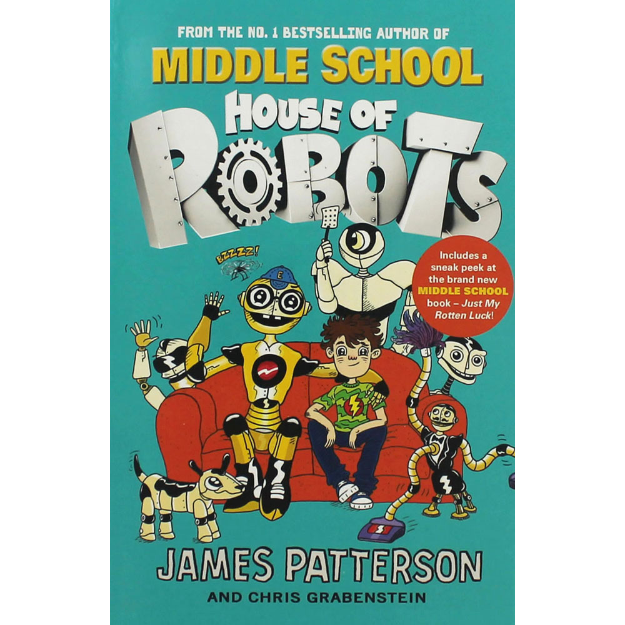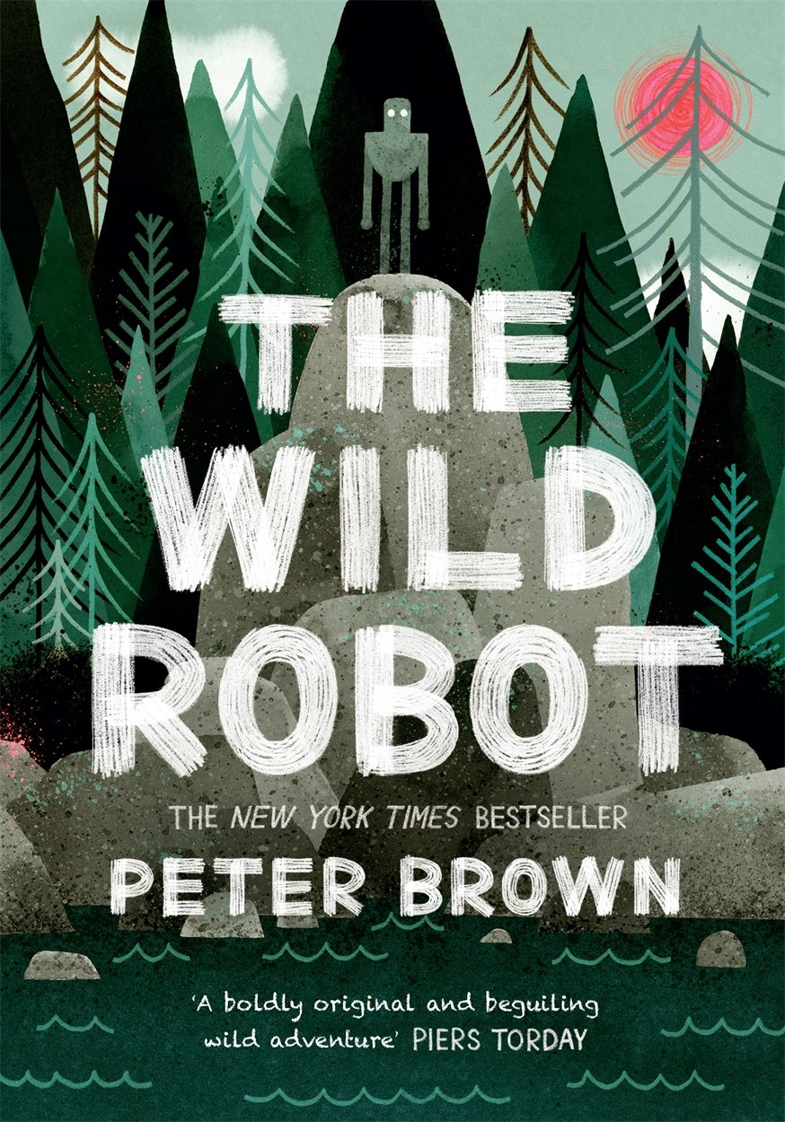

Geography

In Geography our focus will be upon where robots originate from and where they are made.

History

In History we will be looking at chronology of robots and how they have affected our lives, past and present.

Art

In Art we will be having a look at the artist Eric Joyner and having a go at creating our own.

Modern Language

Within French, we will be continuing our knowledge on numbers whilst looking at hobbies and weather.

RE

In RE we will be focusing upon Pentecost.

Computing

Throughout computing in the summer term we will be looking at databases and presentation.

PE

During the Summer term, our focus for outdoor PE will be athletics with a run up to sports day. Whilst we will be giving robot dancing a go throughout our indoor PE lessons.

Music

During music, we will be having a go at composing our own music whilst using different aspects of material we may use to make a robot.

Science

This term in Science, we will be focusing upon electricity, sound and light. This links well into our theme of Robots where we will hopefully be in cooperating some of our scientific knowledge into creating our own Robots.

Maths

In Maths this term we will be continue to expand our knowledge on place value, multiplication and division and addition and subtraction. We will also be looking at money, time, co-ordinates, weight and capacity.

English

Within our English lesson we will be focusing on all things Robots. We will be looking at explanation texts of how certain robots work and having a go at writing our own robot stories. Linking again to our topic, we will also be looking at script writing for commentary of the programme Robot wars and writing instructions for our own robot.