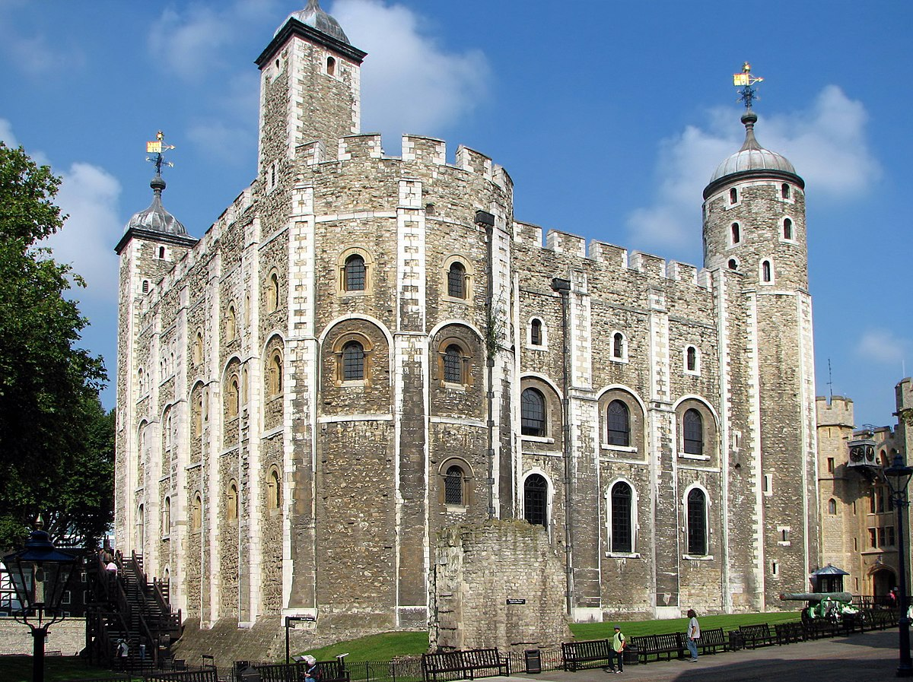

ICT

In ICT, we will begin the term by learning about internet safety including the importance of staying anonymous online when appropriate. The children will learn how to deal with cyberbullying and to reflect on their own digital footprint and behaviour online.

We will continue the term using computers to research a Tudor figure and then to present that information in an interesting way using power point.

English

In English, our class books will be The Prince, the Cook and the Cunning King, The Tudors: Kings, Queens and scribes , Tudor tales: The Maid, the Witch and the Cruel Queen, The Actor, the Rebel and the Wrinkled Queen and My Friend Walter. We will look at stories set in Tudor times exploring settings, plots and characters as well as journalistic writing and persuasive writing linked to our science. In the second part of the term, we will be explaining how the digestive system works, writing stories with flashbacks and write a biography about a key Elizabethan character. .

Science

In Science, we will be learning all about animals and their habitats, how to classify them and consider the impact of environmental change. We will look at plants that were discovered during Tudor times and identify some of the key differences between the habitats. During the second part of the term, we try to help a Tudor with a terrible diet to understand and explain how the digestion system works. Similarly, we will try to help Elizabeth 1st know why her teeth are so decayed and falling out doing some scientific investigations. We will conclude by interpreting and constructing food chains.

Art and Design

In Art, we will be exploring sketching and painting and will use our skills to create a self-portrait in the Tudor style. We will explore using paint to create mood, as we create different versions of our portraits using different colours. We will also use printing techniques to create a border.

History

In History, we will be exploring who the Tudors were and how they came to power, plotting the key events on a timeline. We will look at the themes of money, power and family life and find out what kind of leaders the Kings and Queens were. We will look at marriages, divorce and the importance of a male heir as well as how religious differences caused unrest and wars. We will consider the legacy of the Tudors including on Gloucester and our local area e.g. Berkeley Castle Estate.

**Treason, Traitors and The Tower.**

Design and Technology

In DT, we will build a layered picture of the Tower of London. This picture will feature moving parts such as Yeoman with moving limbs, raven with moving mouth, moving flags and a hand waving and bobbing up and down in prison. We will create various levers and linkages to add the moving parts.

Music

In Music, we will be learning about Tudor Music. We will be focussing on identifying and appreciating the music and saying what it has in common. We will also beging to identify with the work of Mozart and orgainse rythms in call and response. .

French

In French, we will be learning classroom instructions, parts of the body, family and friends using what we learn in simple dialogue.

Geography

In geography we will compare the features of villages and cities, using maps to recognise, and locate features. We will use aerial maps and OS maps, beginning to use some standard symbols. We will plan a journey to a place in England significant in Tudor times.

Maths

In Maths, we will be focusing on number and understanding Place Value, as well as exploring how to solve problems and strengthen our reasoning skills. We will also be learning shapes in geometry. We will work hard to learn our multiplications and have weekly tests.

PE

In PE, we will be primarily focusing on Netball and Net games. PE will take place on **Tuesday** and **Thursday**. Both sessions will be outdoors.

RE

In RE, we will be learning about The Trinity and how people mark significant stages of their lives. They will look at different examples, compare, make connections and ask and answer questions.

PSHE

In PSHE, we will be learning about Being Me in My World and Celebrating Differences.



Children need their PE kit brought into school on their designated days. Elm will need their PE kit on **Monday** and **Thursday** each week. At the end of these days, your children will need to take their PE kits back home and these will need to be washed and cleaned in preparation for the next PE day. Whilst we acknowledge this may be more time consuming than original conduct, it is in alignment with government measures.

A PE kit should include a Cam Woodfield Junior t-shirt, black or blue shorts and daps or trainers. It is recommended that children have warm clothes for outdoor PE. This can include a jumper and jogging bottoms.

Finally, if all children’s clothing can be named it makes it easier to return if lost.

Homework will be handed out every Friday and children will have until the following Wednesday to submit any work. This may change if a homework project lasting more than 1 week is set, however this will be communicated to the children and parents

Alongside homework, children will have weekly spellings and times tables. They are also expected to read regularly and should be recorded in their reading record. These are considered part of the homework for the week.

This year there will be a particular focus on spellings and times tables (including division facts).

Times Tables test

Times tables: As a school we are focusing on times tables. It is the expectation of the National Curriculum that children learn their times tables with rapid recall. This means your child will need to learn each times table off by heart- without having to ‘work it out’.

**Friday -** Spelling test

Spellings: The Government have outlined both spelling patterns and exception words that your child must learn.

Children will receive spellings each week and will be tested the following week. Please make sure you are practising the spellings regularly throughout the week. It is important that your child can spell these words and use them within the context of a sentence.