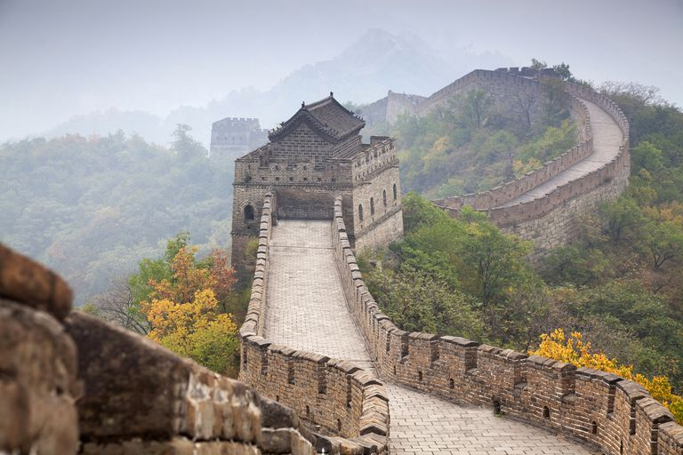

In English, we will be using ‘The Firework Maker’s Daughter’ to inspire our writing this term, where we will write our own persuasive argument, narrative poem and narrative from another perspective within the story. We will also use ‘The Willow Pattern’ story to plan our own legends and journalistic form of writing.

In Science, we will be focusing on Light where we will be learning how light travels, as well as explaining how we can see objects. We will also be learning about electricity: the relationship between the amount of cells in a circuit and the brightness of a bulb or volume of a buzzer. Alongside these units, we will be revisiting how to work scientifically when we carry out investigations.

In History, we will be researching and gathering effective information about the Shang Dynasty. We will record the key events in chronological order and consider how Ancient China has impacted upon China today.

In Music, we will be listening to and appraising Chinese celebration music to help us to compose our own music that celebrates the year of the rat.

In French, we will be learning how to say different jobs and members of the family, also to describe items within the home and key words related to Easter.

In Computing this term, we will be researching the app market in preparation for building our own group app. We will then apply the research to creating our own app interface.

In Maths this term, we will be focusing on calculating using fractions, decimals and percentages, as well as, learning about ratio, proportion and algebra. In geometry, we will identify the area and volume of shapes and convert between units of measure. We will also learn strategies for problem solving in these areas of the curriculum.

In Geography, we will continue to build on our location knowledge by studying where China is in the world, in relation to deserts and the latitude and longitude. We will also compare the different human geography in China by looking at how much it costs to live in different parts of China and why. We will apply this understanding to plan a journey across the Great Wall of China.

In RE, we are going to be focusing on Christianity and answering the question ‘Why do some people believe in God and some not?’ We will also be considering the key question ‘What do Christians believe Jesus did to save people?’

Our Art and Design Technology this term will focus on designing and producing our own item of clothing for a Chinese celebration. We will be learning different stitching techniques to apply to our design.

During our PE sessions, we will be developing our Tennis skills. We will also be learning a traditional Chinese martial art, Tai Chi, which we will share during our Chinese celebration day. As well as this, our swimming sessions will be taking place in the first half of the term.

Our PSHE this term focuses on ‘Dreams and Goals’ and ‘Healthy Me’.

Travelling the Great Wall of China

Year 6

Spring Term

Children need their PE kit in school at all times. Although we try and stick to the same 2 days for PE it is inevitable that for some weeks this will change due to unforeseen circumstances. For this reason we ask that each child has their PE kit in school at all times.

A PE kit should include a Cam Woodfield Junior t-shirt, black or blue shorts and daps or trainers. It is recommended that children have warm clothes for outdoor PE. This can include a jumper and jogging bottoms.

Finally, if all children’s clothing can be named it makes it easier to return if lost.

Homework will be handed out every Friday and children will have until the following Wednesday to submit any work. This may change if a homework project lasting more than 1 week is set, however this will be communicated to the children and parents

Alongside homework, children will have weekly spellings and times tables. They are also expected to read regularly and should be recorded in their reading record. These are considered part of the homework for the week.

This year there will be a particular focus on spellings and times tables (including division facts).

Times Tables test

Times tables: As a school we are focusing on times tables. It is the expectation of the National Curriculum that children learn their times tables with rapid recall. This means your child will need to learn each times table off by heart- without having to ‘work it out’.

**Friday -** Spelling test

Spellings: The Government have outlined both spelling patterns and exception words that your child must learn.

Children will receive spellings each week and will be tested the following week. Please make sure you are practising the spellings regularly throughout the week. It is important that your child can spell these words and use them within the context of a sentence.