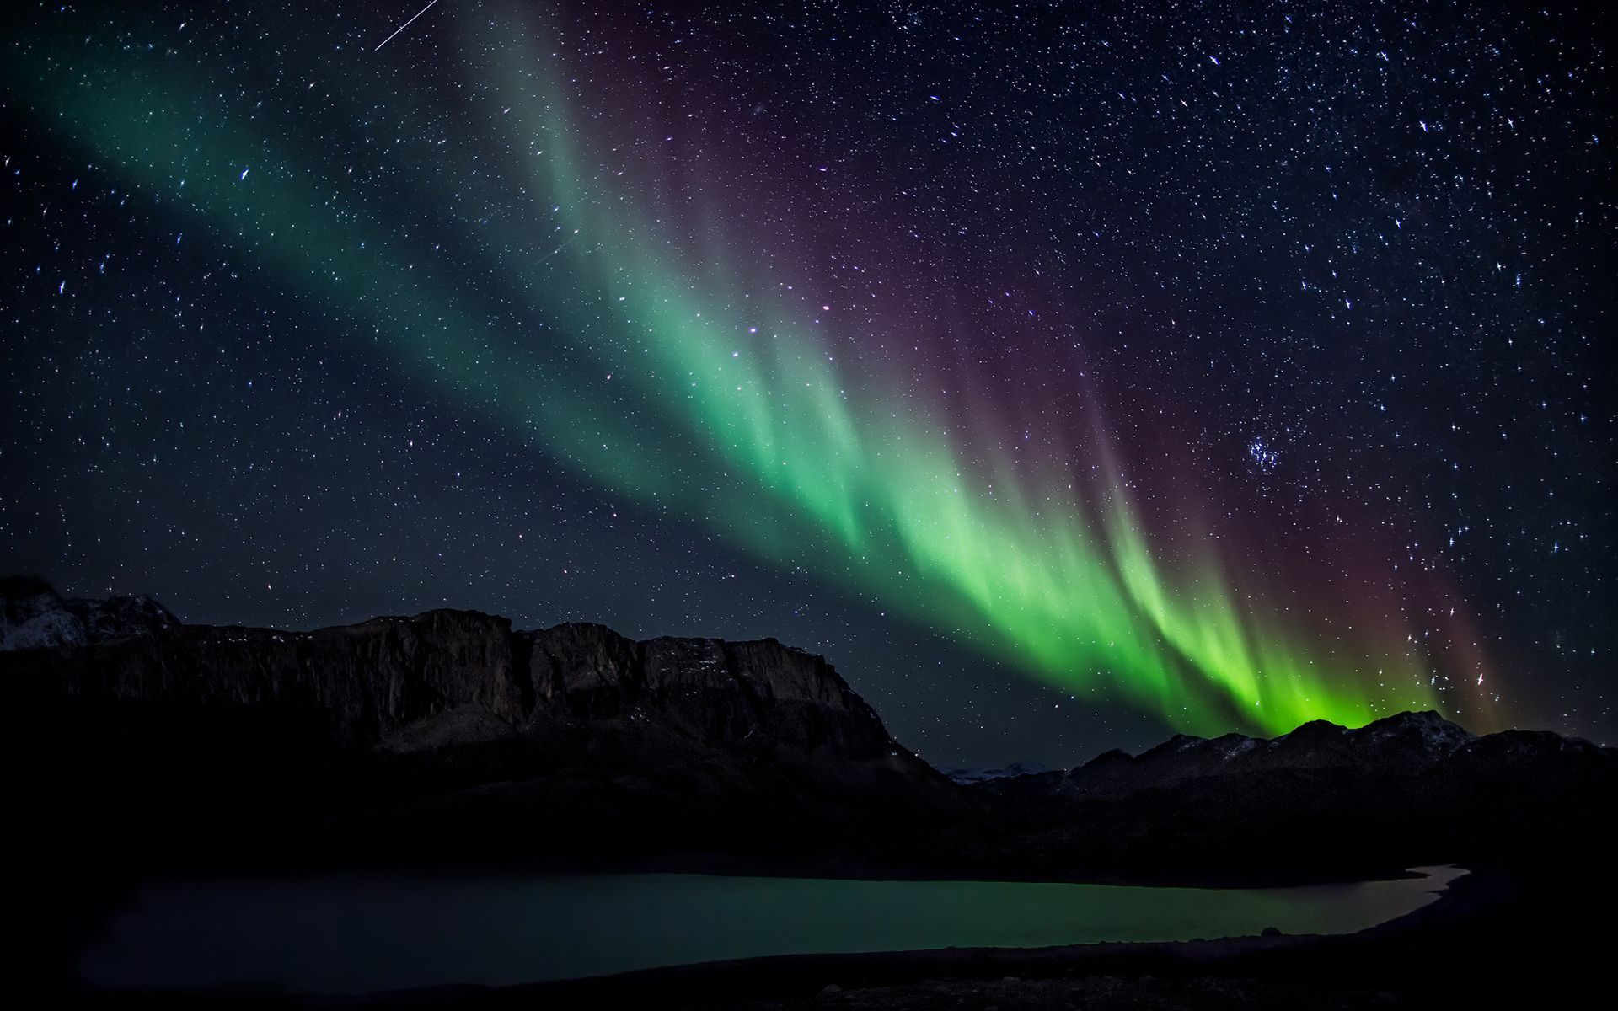

In science, we will be learning all about electricity and lights. We will be focusing on how and why we see things as well as how electricity works. We will also be finding out ways we could help people who live in the Arctic Circle when it is always dark during the winter and when it is always light during the summer.

In RE, we will be trying to answer the following questions:

For Christians, what kind of king is Jesus?

How does faith help people when life gets hard?

In English, we will be reading the book ‘Sky Song’ by Abi Elphinstone. This will inspire many of our fictional writing tasks as well as writing non-fiction texts about the northern lights. We will continue to develop and apply our grammar skills through writing a range of different text types including explanation texts and our own fantasy stories. We will continue to develop our comprehension skills by reading many different text types and asking questions and discussing them in detail.

In maths, we will be focusing on revision of calculation, shape, space and measure. We will be applying all of this knowledge to a range of problems to continue to develop our problem solving skills. We will also be applying our mathematical knowledge to a range of algebra problems. Finally, we will be carrying out a range of open-ended investigations allowing us to really explore a range of mathematical skills.

The Journey to the Northern Lights

Year 6

Summer Term

In geography, we will be continuing to develop our location knowledge as well as looking at the different environments of the places the northern lights are seen. We will also been looking at human geography and investigating how this is having an effect on climate change.

In history, we will be looking at many of the famous explorers who have reached the North Pole. We will also be looking at the history of Scandinavian countries and comparing it to some of our own history.

In DT, we will be using what we learn in science to construct a light source for people living and exploring the Arctic Circle.

We will be researching Scandinavian artists for art and looking at how they experiment with light and dark.

In PE, we will be working on our strength and stamina during athletics, We will also be developing our throwing and catching skills in rounders.

In music, we will be creating our own northern lights composition using a range of instruments. We will also begin to use notation to record this composition.

In ICT, we will be using time-lapse photography to record how environments change over time. We will also use a range of different equipment to record data on during our science lessons. We will also begin to write a blog about our findings on climate change.

In French, we will be learning vocabulary for how to book and plan a holiday. This will include vocabulary for types of accommodation, travel options and holiday activities.