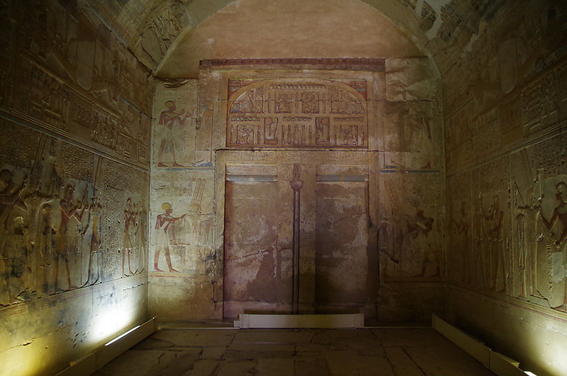

Science

* Make a dinner which is good for caring for our teeth.
* Draw and describe the mouth and teeth of a carnivorous monster from Egyptian Mythology.
* You have gone back to Ancient Egypt to rescue the Ancient Egyptian, who all suffered with their teeth. Explain to them why it is important to look after their teeth and how to do so.

R.E.

* Make a mind map showing at least 5 reasons why Christians’ pray. How does this show their belief? Do you think it is a good idea or not? Write a short paragraph and give your reasons.
* Farming and Harvests are a time to be thankful. Make a short video presenting what you have found out about Ancient Egyptian Harvests, who they worshipped and thanked. How is this similar to how Christian’s show their faith and thanks at this important time of year?
* Research how Ancient Egyptians worshipped at home and compare this to some of the ways how Hindus worship at home. Write a journal page presenting your findings.

**The Search for the Tomb of Osiris**

**Y4**

**Homework Autumn Term 2021**

Autumn Term

Geography

* Draw a map of Modern Egypt. Identify and label some of the key physical features e.g. The River Nile. as well as important towns and cities. Use appropriate symbols to show these and add a key.
* Research The River Nile. Explain why it was and still is so important to people living there and how it helps support life, farming and traditions.

History

* Use historical sources of evidence to research what an Egyptian ‘Death Mask’ is and why it was important (you can link this to one of the art tasks)
* Research what is was like for a child in Ancient Egyptian times. Use pictures and illustrations to present your findings as a diary.
* Find out about the pyramids including how they were built and what they were like inside. Present in a creative way e.g. a labelled model, a log, a flap book e.t.c.

P.E.

* Create a “mummy’s guide” to dribbling, passing or shooting
* Design an outfit for a Pharoanic dancer

The Arts

* Create an Egyptian wall painting by using a “wash” on paper with paint to give a stone effect and printing Egyptian symbols onto it by using a printing block and paint.(Hint: Potatoes can make good printing blocks or string glued to cardboard.)
* Research, design and create a piece of Egyptian jewellery or clothing.
* Create an Egyptian “Death Mask” ensuring you add texture and use materials to give it a 3D shape.
* Research foods the Ancient Egyptians would have eaten and follow a recipe to reproduce an Ancient Egyptian dish that you’d love to try.

|  |  |  |  |  |
| --- | --- | --- | --- | --- |
| For homework this term, you need to select 10 pieces that you would like to do to help you discover more about our theme and record each one using the table below. You need to select at least one activity from each subject box. Each piece of work that you produce must be of high quality, as they will be shared with your class. Be as creative as you can and have fun completing each activity, you might even like to do an activity as a whole family. Your class teacher will regularly check-in with you to find out how you are getting on with each project. Once you have completed a piece of work, remember to bring it into school or take a photo, so that your class teacher and class can see the fantastic work that you have produced. All 10 pieces must be completed and handed in by Thursday 16th December. | | | | |
| 1. | 2. | 3. | 4. | 5. |
| 6. | 7. | 8. | 9. | 10. |