How can I help at home?
Top strategies for helping your child manage their emotions.
In order to understand how we can start to support someone with their emotions, we need to understand where we process emotions & what helps us to do that.
When we talk about managing our emotions, this happens in a part of our brain called the Executive Function.
This area also controls our inhibitions, concentration, working memory, self-awareness, self-control, self-motivation. We need these to self-regulate.
When the Executive Function is struggling or overloaded, we lose the ability to control our responses.
Sometimes children are unable to tell the difference between sensations, states and feelings and to move between them successfully.
When a person experiences an emotion they don’t recognise, they overact, become confused, overwhelmed, vulnerable and unsafe.
How can you support?
- Be a good role model - children very often do what they see. If their parents struggle with self-regulation, they may too.
- Begin to learn your child’s triggers.
- Just as you have helped your child identify and name different parts of their body, you can help them learn about different emotions. When your child overwhelmed by emotion, you can help by:
Naming the emotion – “I can see that you are feeling sad”
Identifying the cause of the emotion – “I think you are feeling sad because…”
Offering reassurance – “It’s okay to feel sad…” Offering a reason and a possible solution.

You can also express and describe your own emotions:
“I’m so excited that …”
“I am disappointed that …”
“I am frustrated that …”
Doing so will show that everyone feels these things, and there are appropriate ways to express them
Training your child to recognise their emotions, eventually they will verbalise to a trusted person.
Use an emotions thermometer to understand how to rate their emotions. Relate how the body looks & feels at different times on the scale.
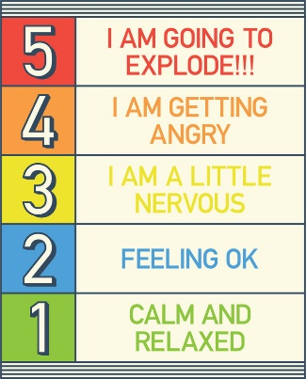
Work with your child to develop ways to calm them down. This may include familiar smells, soothing textures, a walk, stretching or visualising something positive. Finding a safe area to go to & training a them to go there in times of crisis is very important.
Behaviours which harm self, others or the environment can be redirected into acceptable responses which allow the physical expression of those ‘big feelings’. By developing a toolbox of safe outlets for these emotions, we can guide the child into behaviour modification, rather than repeatedly punish – which teaches fear and resentment.
Things to try might include: using a pillow, punching bag or other object for ‘acceptable hitting’; stress balls to squeeze hard; silicone “teething” toys for biters to express their frustration; safe spaces to run around, kick or throw balls or otherwise work through physical signs of overwhelm.
For other children, a safe space in which to retreat to allows them to regulate their feelings in private. Create a nesting space with cushions, soft toys, books and ‘calm down’ items, perhaps inside a play tent or other enclosed space. Rather than be placed in ‘time out’ as punishment, your child is guided and chooses when they need some space away from others to process what they have experienced.

