How can I help at home?
Top strategies for helping your child manage their anger.
The following information, coupled with advice from NHS direct, can be helpful in supporting children to manage their emotions and anger.
What is Anger?
Anger is a normal and useful emotion. It can tell children when things are not fair or right but anger can become a problem if a child's angry behaviour becomes out of control or aggressive.
Why is your child so angry?
There are lots of reasons why your child may seem angrier than other children, including:
- seeing other family members arguing or being angry with each other
- friendship problems
- being bullied – the Anti-Bullying Alliance has information on bullying
- struggling with schoolwork or exams
- feeling very stressed, anxious or fearful about something
- coping with hormone changes during puberty
It may not be obvious to you or your child why they're feeling angry.
If that's the case, it's important to help them work out what might be causing their anger.

Tackle anger together
Team up with your child to help them deal with their anger. This way, you let your child know that the anger is the problem, not them.
With younger children, this can be fun and creative. Give anger a name and try drawing it – for example, anger can be a volcano that eventually explodes.
How you respond to anger can influence how your child responds to anger. Making it something you tackle together can help you both.

Help your child spot the signs of anger
Being able to spot the signs of anger early can help your child make more positive decisions about how to handle it.
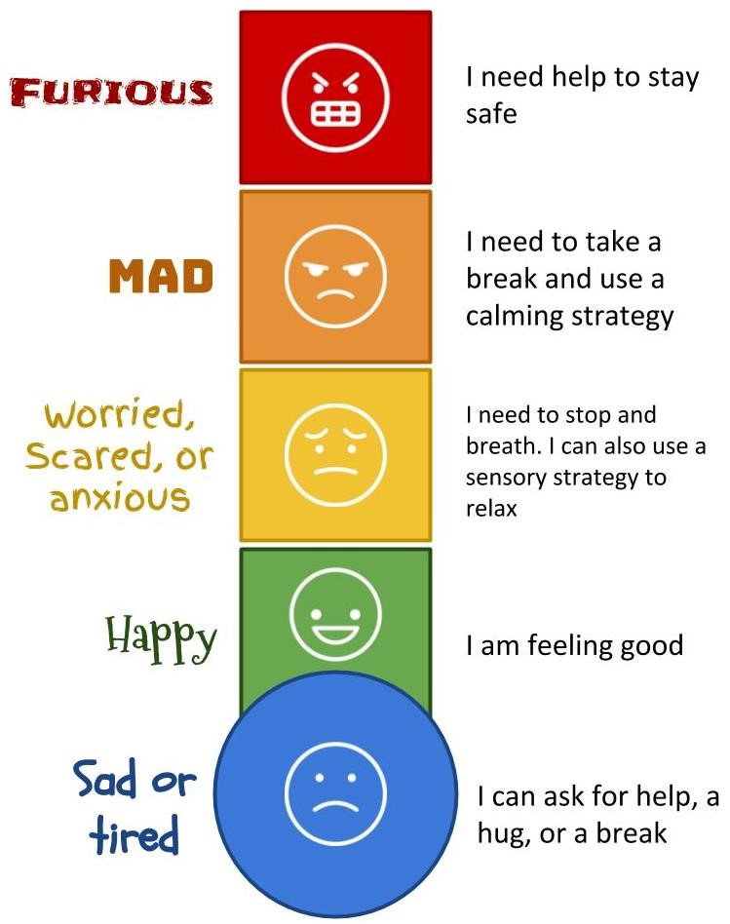
Talk about what your child feels when they start to get angry. For example, they may notice that:
- their heart beats faster
- their muscles tense
- they clench their teeth
- they make a fist
- their stomach churns

Anger tips for your child
- Work together to try to find out what triggers the anger. Talk about helpful strategies for managing anger.
- You could encourage your child to:
- count to 10
- walk away from the situation
- breathe slowly and deeply
- clench and unclench their fists to ease tension
- talk to a trusted person
- go to a private place to calm down
- If you see the early signs of anger in your child, say so. This gives them the chance to try their strategies.
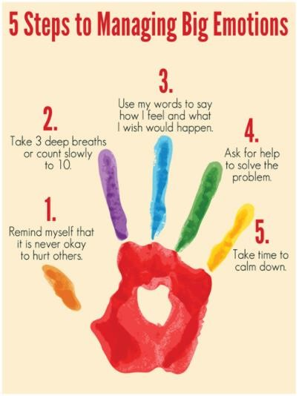

Encourage regular active play and exercise
- Staying active can be a way to reduce or stop feelings of anger. It can also be a way to improve feelings of stress, anxiety or depression,
- For older children or young people, this could be simple activities, such as:
- a short walk
- jogging or running
- cycling
- Read more about physical activity for children and young people.

Be positive
- Positive feedback is important. Praise your child's efforts and your own efforts, no matter how small.

- This will build your child's confidence in their ability to manage their anger. It will also help them feel that you're both learning together.

When to seek help for anger in children
- If you're concerned your child's anger is harmful to them or people around them, you could talk to a:
- GP
- health visitor
- school nurse
For more support with anger in children, you could phone the YoungMinds parents' helpline free on 0808 802 5544 (9.30am to 4.00pm, Monday to Friday).
The YoungMinds website also has:
- a parent’s guide to responding to anger
- information for children about dealing with anger
- MindEd for families have information on anger and aggression in children.

